The Golden Rule
You need to KISS
- Keep
- It
- Simple
- Stupid
Don't come up with crazy and elaborate ideas until you’re faster and more experienced filming.
Remember how I said my simplest videos surprised me at how powerful they were…this is the same.
Every time you come up with an idea for filming, the first question to ask yourself is…"how can I make this simpler, simpler for me to film and simpler for the viewer to understand?"
How To Frame Your Shots
- Keep your subject, item, or main focal point over the intersecting points on the grid.
- Placing points of interest at the intersections of the grid lines naturally draws the viewer's eye to these points, making the image more engaging.
- This guides the viewer’s eyes in a natural way, often leading them to explore more of the image than just the main subject. It also allows for more background elements to be included, which can add context and depth to the story being told.
- Keep in mind, although this is called the rule of thirds, it's a guide not a set in stone rule.
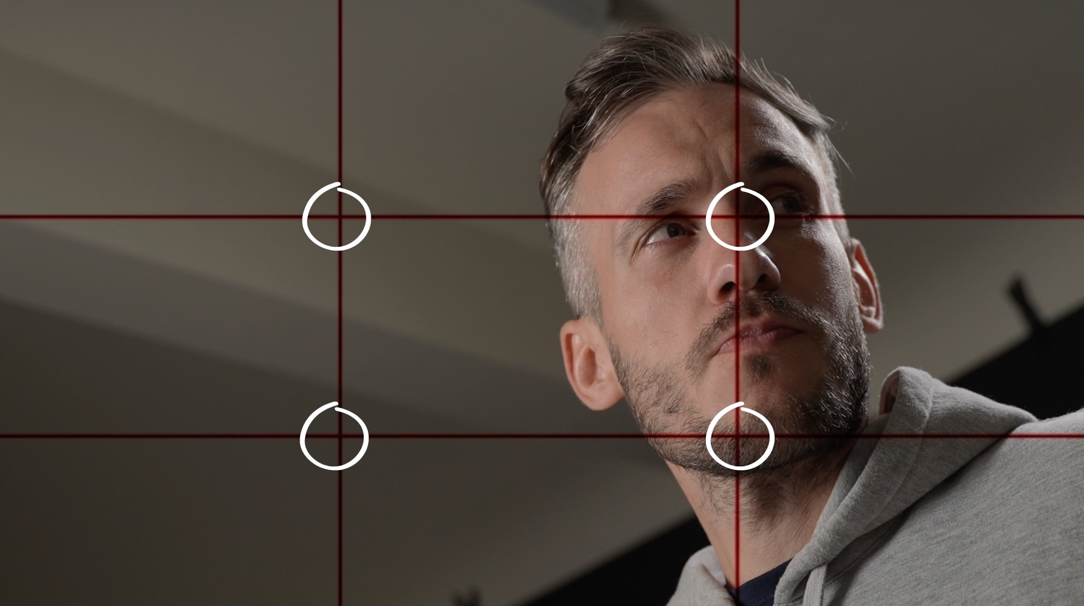
Camera Angles I Stick To
Wide Shot
Purpose: Establishes location or context.
Tip: Use it to set the scene or convey emotions like loneliness.
Medium Shot
Purpose: Focuses on the subject, usually filmed from the waist up.
Tip: Ideal for mimicking the distance of a real-life conversation; great for focusing on actions.
Close-Up Shot
Purpose: Highlights detailed expressions.
Tip: Use it to emphasize important emotional moments or critical story points.
Extreme Close-Up
Purpose: Focuses intensely on a detail.
Tip: Ideal for emphasizing a significant detail in your story.
Low Angle Shot
Purpose: Gives the subject a sense of power or authority.
Tip: Shoot from a low point, aiming upwards to make the subject appear larger and more imposing.
High Angle Shot
Purpose: Makes the subject appear smaller or weaker.
Tip: Shoot from a higher point, aiming downwards to create a sense of vulnerability or inferiority.
Dutch Angle
Purpose: Creates a sense of unease or disorientation.
Tip: Tilt the camera slightly to make the horizon appear off-balance.
Dirty Frame
Purpose: Adds depth and context.
Tip: Position something in the foreground to create a layered effect and a more dynamic frame.
Over-the-Shoulder Shot
Purpose: Provides the viewer's perspective.
Tip: Frame the shot from just behind a subject, focusing on what they see or interact with.
Point of View (POV) Shot
Purpose: Shows the viewer's direct perspective.
Tip: Film as if the camera is the eyes of the subject, to fully immerse the viewer in the experience.
Tip for Choosing the Right Angle
Ask yourself: "What will show the most important thing here that will help my viewers understand what has happened and show rather than tell?"
Time-Saving Production Tricks
Simplify Shooting Approach: Opt for the simplest way of shooting, such as the "wide close wide" technique, to balance time versus impact efficiently.
Shoot in 4K and Frame in Edit: To avoid the complexity of filming yourself, shoot in 4K and then adjust the framing during the editing process. This allows for various shot types like close, medium, or extreme close-up without changing the camera setup.
Frame Before Recording: To reduce editing work and file sizes, always set up your shot and frame it before hitting the record button.
Use a Smartphone for Remote Control: Utilize a smartphone with an app (like Sony Cameras' Image Edge) to monitor and control your camera remotely. This facilitates easier recording without needing to be behind the camera, especially for shots where your face isn't shown.
Outdoor Lighting for B-Roll: To save time on adjusting lighting for B-roll, shoot outdoors using natural light. This eliminates the need to move lighting equipment, although you should be mindful of changing light conditions due to clouds.
Simple Motion Effects: Instead of using sliders and gimbals, which can be cumbersome to set up, achieve motion effects by shooting in slow motion and using body movements (e.g., lunging side to side). This mimics the effect of a slider but is much quicker and easier.
How to Come Up With Ideas for Visual Storytelling
Use Metaphors: When you develop a metaphor, it will guide the visual elements you can shoot, making your storytelling more engaging and meaningful.
Find Inspiration from Content Creators: Watching talented creators on YouTube, Netflix, TikTok, or other platforms can spark creative ideas. Creators can inspire you with their unique approaches to content creation.
Consume Various Content: Regularly watching different kinds of content exposes you to new viewpoints, ideas, and experiences. This not only fuels creativity but also helps you understand viewers better and keep up with trends.
Learn from Successful Content: Observing what keeps you engaged in others' content and borrowing those techniques can be adapted to your niche for effective storytelling.
Overcome Writer's Block: If you're struggling with ideas, watching something engaging can help overcome the block and stimulate creativity.
How to Plan Your B-Roll
Plan B-Roll Simply: While writing your script, think about how you can visually represent your points. Note down any good ideas spontaneously without planning every camera angle in detail. Shooting a wide shot, a close-up, and possibly a third angle for each scene can be a straightforward approach, and then you can cut them together during editing.
Color-Coding Script for B-Roll: Use a digital document (like Google Docs) to color-code parts of your script that require B-Roll. This helps in planning without needing a separate document, streamlining the workflow.
Add Filming Notes: Use the comments feature in your document to add notes about filming specifics, keeping the planning process simple.
Creators I go to for inspiration
https://www.youtube.com/@DanMace/videos
https://www.youtube.com/@GawxArt
https://www.youtube.com/@NiklasChristl

